

Aero 210S AATF Design Project
Fall 2025
200 pts

Overview
The Affordable Advanced Tactical Fighter (AATF) Design Project will allow you to apply concepts from aerodynamics, aircraft performance, and aircraft design to create an affordable replacement for the F-22. Given a Request for Proposal (RFP) for the AATF, you will analyze the requirements, determine the mission parameters and design constraints, employ the Jet11 design program to optimize a design configuration, examine alternative designs as part of a team presentation, and develop an individual analysis for the program office on the viability of your design and next steps for the project.

Desired Learning Outcomes
By the end of this project, you will be able to:
- Analyze an RFP to determine mission performance requirements and design constraints
- Apply your understanding of aerodynamics and aircraft performance to design and optimize an aircraft based on RFP requirements
- Employ Jet11 design software to develop, iterate, and optimize an aircraft design to meet specified requirements at minimum cost
- Analyze and compare design alternatives, evaluate performance against design requirements, synthesize findings, and provide recommendations
- Navigate the Jet11 design software with proficiency
- Understand the structure, style, and methodology inherent in technical communication

Work
The AATF Design Project consists of five Graded Exercises (GE) and the final design submission:
- GE 1: Mission Analysis (15 points – due lesson 30)
- GE 2: RFP Constraint Analysis (15 points – due lesson 32)
- GE 3: AATF Design Iteration I – Jet11 File and Glider Cutout (15 points – due lesson 33)
- GE 4: Design Analysis Graded Draft (15 points – due lesson 36)
- GE 5: Analysis of Alternatives (AoA) Brief (40 points – group slides due lesson 37)
- Final AATF Design Analysis and Jet11 File (100 points – due lesson 40)

Supplementary Information:
- Appendix A: AATF Request for Proposal (RFP)
- Appendix B: AATF Mission Analysis Template
- Appendix C: Preformatted Constraint Analysis Spreadsheet
- Appendix D: AATF Design Analysis Template
- Appendix E: Analysis of Alternatives Template

This page intentionally left blank

GE 1: Mission Analysis (20 points)
Due: In Blackboard prior to the beginning of Lesson 30
Overview
GE 1 will help you become fully familiar with the AATF Request for Proposal (RFP), the AATF mission, and the design project requirements. For this exercise you will analyze the RFP and develop a Mission Analysis (MA) slides-only brief summarizing the AATF performance requirements, mission parameters, and mission profile. Leveraging your understanding of fluids and aerodynamics from Phase 1 of AE210, you will program the AATF mission parameters into Excel to build a mission table and use that data to create a mission profile chart for your brief. Your mission table will mirror the mission table in Jet11, which you will use frequently while creating and optimizing your design. Your MA brief will become the Mission Analysis portion of your final design analysis.

Objectives
The GE 1 objectives are as follows:
- Analyze an RFP to determine mission performance requirements and identify design constraints
- Apply your understanding of fluids and aerodynamics to perform technical mission analysis
- Practice programming and creating charts using a spreadsheet to analyze data
- Develop technical communication skills

Work
GE 1 consists of the following graded elements:
- (10 pts) Mission Analysis slides-only brief including
  - Slide 1 (1 pt): Title Slide including your name
  - Slide 2 (1 pt): Overview Slide
  - Slide 3 (2 pts): 2-3 bullets summarizing what threshold and objective requirements mean
  - Slide 4 (2 pts): Single Table depicting RFP Threshold and Objective Requirements
  - Slide 5 (2 pts): AATF Mission Table
  - Slide 6 (2 pts): AATF Mission Profile Chart
  - Slide 7 (blank): Objective Constraint Diagram
  - Slide 8 (blank): Threshold Constraint Diagram
- (5 pts) Supporting Excel document showing calculations used to create the Mission Table

Instructions:
- Use the template in Appendix B as a framework to build your MA brief
- You may receive help from anyone on how to program and create a chart in Excel or on how to make tables and charts in PowerPoint
- You must submit your own individual slides-only brief and Excel spreadsheet
- Save your brief as a PDF document named Lastname Firstname_GE 1 MA Brief.pdf; save your Excel document as a file named Lastname Firstname_GE 1 Mission Table.xlsx
- Upload your MA Brief PDF document and Excel file to the GE 1 Assignment in Blackboard prior to the start of Lesson 30

GE 2: RFP Constraint Analysis (15 points)
Due: In Blackboard prior to the beginning of Lesson 31
Overview
GE 2 will introduce you to constraint analysis. For this exercise, you will program the constraints into JET to evaluate the RFP mission parameters and generate constraint diagrams for both the AATF Objective Requirements and the Threshold Requirements. The constraint diagrams will allow you to analyze each constraint and determine the driving constraints. Your constraint diagrams will help you understand the design points for both the Objective and Threshold Requirements. You will use your constraint diagram intensively in JET while creating and optimizing your design.

Objectives
The GE 2 objectives are as follows:
- Analyze an RFP to determine design constraints and identify driving constraints
- Apply your understanding of aircraft performance to perform technical mission analysis
- Practice programming and creating charts using a spreadsheet to analyze data

Work
GE 2 consists of the following graded elements:
- (10 pts) Constraint Analysis slides for your final Design Analysis brief including
  - Slide 7 (5 pts): Objective Constraint Diagram highlighting desired design point
  - Slide 8 (5 pts): Threshold Constraint Diagram highlighting desired design point
- (5 pts) JET11 files used to build both Objective and Threshold Constraint Diagrams

Instructions:
- Reference the AATF RFP for both Objective and Threshold requirements (Table 2 in Attachment 2 on page 6). Assume Max Thrust and load factor n = 1 unless otherwise specified in the RFP requirements
- Use the JET 11 AE210 Baseline.xlsm spreadsheet to input the RFP Table 2 Objective parameters the Main tab, and generate the AATF Objective Constraint Diagram below it.
- Snip your constraint table (area with numbers input above the constraint graph) and constraint graph for your objective and insert them into Slide 7 of your Misson Analysis Brief from GE 1 with the table on the left, and the graph on the right.
- Open another JET 11 file and input the RFP Threshold parameters to generate the AATF Threshold Constraint Diagram
- Snip your constraint table (area with numbers input above the constraint graph) and constraint graph for your objective and insert them into Slide 8 of your Misson Analysis Brief from GE 1 with the table on the left, and the graph on the right.
- Save your Mission Analysis Briefing as a PDF document named Lastname Firstname_GE2.pdf
- Upload your PDF and Excel files to the GE 2 Assignment in Blackboard

GE 3: AATF Design Iteration I
Jet11 File and Glider Cutout (15 points)
Due: In Blackboard prior to the beginning of Lesson 33
Overview
GE 3 will introduce you to design and optimization in Jet11. You will program fundamental aerodynamics equations into the Aero tab to bring Jet11 to life, begin optimizing your AATF design to meet RFP requirements at minimum cost, and use Jet11’s aircraft schematics to manufacture a prototype that you will flight test during the glider flyoff on lesson 36.

Objectives
The GE 3 objectives are as follows:
- Apply your understanding of aerodynamics and aircraft performance to design and optimize an aircraft based on RFP requirements
- Employ Jet11 design software to develop, iterate, and optimize an aircraft design to meet specified requirements at minimum cost
- Develop proficiency with the Jet11 design software

Work
GE 3 consists of a Jet11 file with the following graded elements:
- (2 pts) Aero Tab programmed with three specified equations
- (8 pts) Main and Gear Tabs with initial design iteration of a viable aircraft
- (5 pts) Traced or printed 30” cutout of your design to serve as a model for your glider

Instructions:
- Download the Jet11 file from the Design Project page underneath Assignments on the AE210S course page in Blackboard.
- Save it to your computer anywhere but Downloads as Lastname Firstname_Jet11.xlsx and close the file.
- Reopen your Jet11 file and enable macros when queried by Excel. Note: Jet11 does not autosave! You will need to save your design periodically as you make iterations that you want to keep.
- Input data only into the white cells. Do not overwrite any of the colored cells!
- (2 pts) On the Jet11 Aero Tab (Figure 1), input equations for 3D lift-curve slope, parasite drag coefficient, and induced drag coefficient into the red bordered cells A15, G3, and G10. The yellow cells directly below provide the correct answers so you can verify your accuracy. Reference your equation variables from appropriate cells in the Aero Tab or on the Main Tab.
  - A15: Lift-curve Slope of a 3D Wing per degree (C_{Lα}) (page 173)

  - G3: Subsonic Predicted Parasite Drag Coefficient (page 187)

  - G10: Subsonic Induced Drag Coefficient (page 155)
$$k_{1}=\frac{1}{πe_{o}AR}$$
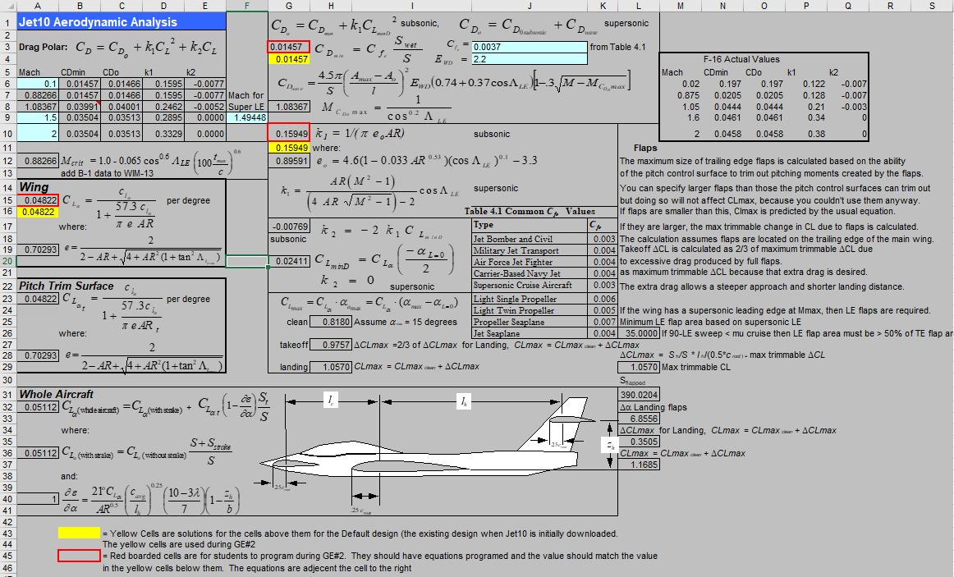
Figure 1: Jet11 Aero Tab
- On the Jet11 Main Tab (Figure 2), optimize your design to meet the RFP requirements at minimum cost. Remember the relationship between total aircraft size and cost.
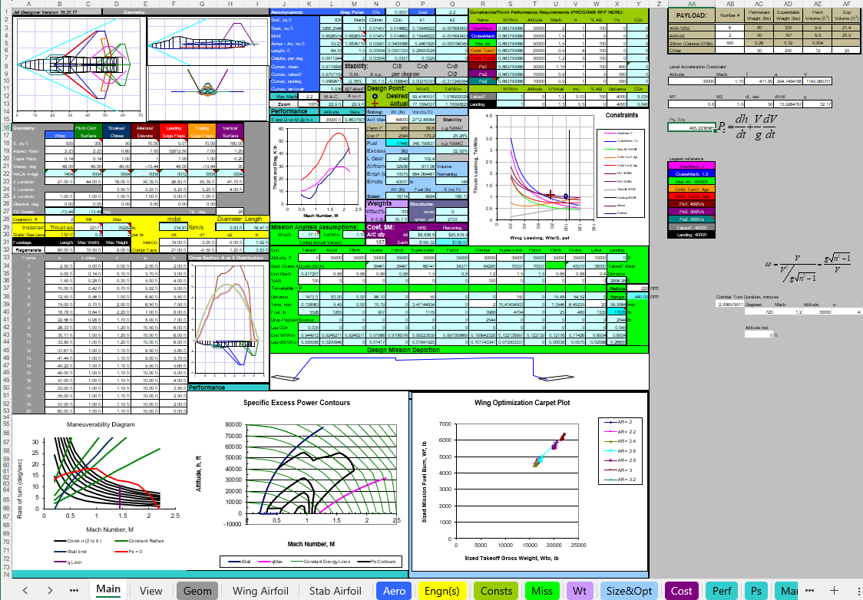
Figure 2: Jet11 Main Tab
- Input the appropriate mission parameters (Altitude, Mach #, %AB, Distance, and Time) for each leg in the mission table (Figure 3) to match the RPF parameters in Attachment 1. This should mirror the process you used to create your mission table for GE 1. Input the mission radius in cell Y37 to meet the RFP requirement.
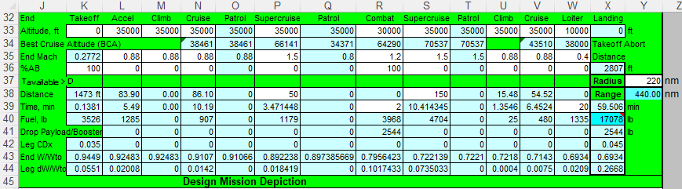
Figure 3: Jet11 Mission Table
- (1 pt) Note the green row across the middle of the Jet11 mission table entitled ‘T_{available} > D’. Each of these blocks verifies that your design has adequate thrust to account for the total drag on that mission leg. As you iterate your design, you will likely notice several of these blocks turning red, which tells you that your total aircraft drag exceeds your thrust available and your aircraft cannot perform that mission leg as currently designed. In this case, you will either need to increase thrust available or decrease total drag to enable your aircraft to meet the mission requirements.
- Use the Jet11 constraint table and constraint diagram (Figure 4) to further analyze your design. Jet11 uses the master equation to generate the constraint diagram, just as you did in GE 2.
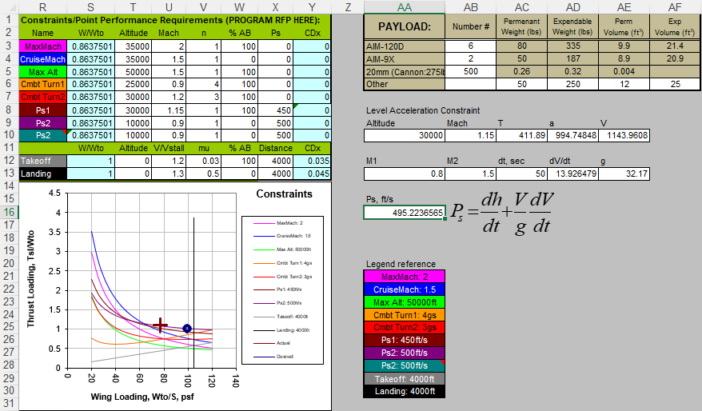
Figure 4: Jet11 Constraint Table, Constraint Diagram, and Payload Table
- (1 pt) Verify that each of the variables in the constraint table matches those specified in the RFP for each requirement. Additionally, verify that the number and type of munitions in the payload table matches the RFP requirement.
- As you iterate your design, try to drive your design point (+ symbol) toward the desired design point (o symbol). Your design point must sit above all the constraint lines (and to the left of the landing constraint line) to meet the RFP requirements. Start by inputting all the objective parameters into the constraint table and try to optimize your aircraft. If you are unable to meet all objective requirements, relax some parameters to the threshold requirements. Designs that fall short of the threshold requirements may not be considered as viable by the customer and are unlikely to earn full points in this project.
- Use the Geometry and Engine(s) sections (Figure 5) to iterate the size and shape of your aircraft stability and control surfaces, number of engines, and installed military thrust. Use cell C29 to adjust the installed military thrust for each engine. After your first change, you can check your design using https://github.com/dellolmstead/AE210GE3Webgrader# to give feedback.
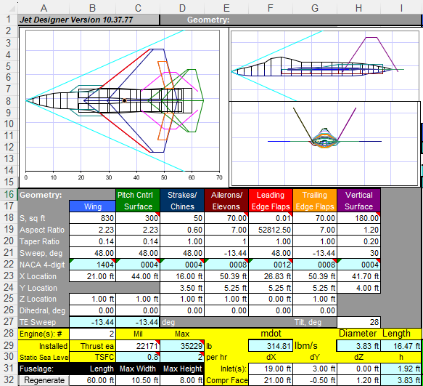
Figure 5: Jet11 Geometry and Engine(s) Sections
- (1 pt) As you iterate your design, the schematics above the Geometry section will automatically update to illustrate your aircraft. Make sure your control surfaces are attached and reasonably placed on the aircraft. You can also try to design for low observable planform alignment.
- (1 pt) As you iterate your aircraft geometry, the parameters in the Aerodynamics section will change. Pay close attention to the stability parameters (lower third, right hand side of Figure 6). Geometry changes may put stability parameters (Static Margin, C_{Lβ}, C_{Nβ}, and C_{Nβ}/C_{Lβ}) out of limits, which Jet11 identifies by making the cell turn red. Apply what you learned in the Performance and Stability phase of the course to refine your design geometry and put the aircraft stability within limits.
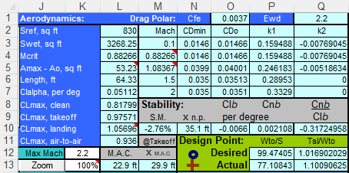
Figure 6: Jet11 Aerodynamics and Stability
- (1 pt) Use the sizing section (right-hand side of Figure 7) to iterate the aircraft weight, payload and volume. Remember, aircraft size (weight) is directly correlated to aircraft cost. Try to reduce the aircraft gross weight (Acft Max Wt – cell O15) to bring down the aircraft cost. Notice the fuel weight (darker blue – cell O18). This is the amount of fuel your aircraft has available. Jet11 determines the fuel available by subtracting payload and structural weight from the aircraft gross weight and assumes that any weight left over is fuel. As you iterate your aircraft gross weight, pay attention to your fuel available, and make sure it meets or exceeds the fuel required, which Jet11 calculates in the mission table (cell X40). Jet11 will identify if your aircraft’s fuel capacity is insufficient by making cell X40 and O19 turn red.

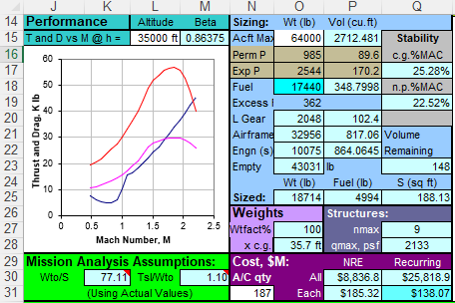
Figure 7: Jet11 Sizing and Cost
- (1 pt) Pay attention to the Volume Remaining in cell Q23. This value will change as you iterate your design to ensure that the outside of the aircraft is bigger than the inside. If your design geometry is such that your aircraft volume is insufficient to fit all its internal components, the volume remaining in cell Q23 will turn red.
- (1 pt) The primary purpose of this design project is to develop an Affordable Advanced Tactical Fighter. Your goal is to design the AATF such that the recurring cost per aircraft (cell Q31) is less than $100M (objective) per copy for a purchase of 187 aircraft, or less than $63M (objective) per copy for a purchase of 800 aircraft. As you iterate your design, attempt to drive the recurring cost per aircraft (cell Q31) below the objective or threshold requirement. You can change the total number of aircraft for the purchase by changing the aircraft quantity value in cell N31.
- The thrust and drag curves on the left side of Figure 7 will help you visualize your design’s thrust available in mil and max thrust relative to the drag for the specified design constraint. If your aircraft’s drag exceeds the thrust available, it will be evident on the thrust curves, and on the mission table where the T_{available} > D cells will turn red. One possible solution to reduce total drag on your aircraft is area ruling.
- Figure 8 illustrates Jet11’s interface for area ruling. You can iterate your design fuselage width and height to optimize your area ruling and minimize drag. The graphic on the right-hand side of Figure 8 will change as you iterate your geometry; your goal is to conform the design red line to the optimal green line. Effective area ruling can frequently reduce the aircraft drag to put the aircraft within parameters to meet the RFP requirements. After you adjust your fuselage width and height, input the maximum width and height dimensions in cells C32 and D32.
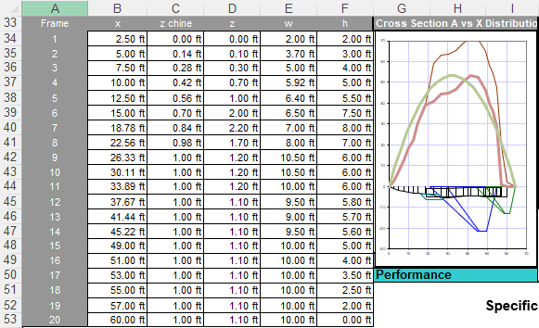
Figure 8: Jet11 Area Ruling
- (1 pt) Verify that your aircraft satisfies the landing gear geometry requirements. Figure 9 illustrates the Jet11 Gear Tab, where you can analyze your landing gear geometry. Jet11 will identify if your design puts the landing gear outside of acceptable tolerances for 90/10 rule, tipback angle, rollover angle, or takeoff rotation speed by turning the values in those cells red. Refine your landing gear geometry, aircraft center of gravity, or structural geometry to put your gear within limits.
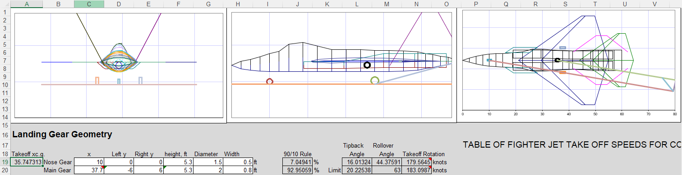
Figure 9: Jet11 Gear Tab
- Remember, this entire process is iterative. Just as pilots need a good instrument cross check to fly at night or in the weather, you will need a good scan pattern as you iterate through each of the Jet11 design interfaces to attempt to optimize your design to meet the RFP requirements.
- GE 3 is intentionally designed as a low-threat exercise to give you an opportunity to create and optimize your design with relatively few points at stake. Try to meet all design requirements but remember that design is an ongoing process. If your first iteration isn’t perfect, apply what you’ve learned to your final design project submission. Once you think you have a complete design, get an unrecorded check by submitting to https://github.com/dellolmstead/AE210GE3Webgrader#
- Once you are content with your result, save your GE 3 Jet11 file as an Excel document named Lastname Firstname_GE3 Jet11.xlsm.
- Upload your Excel file to the GE 3 Assignment in Blackboard.
- Finally, trace or print the God’s eye view of your design (Figure 5, left-hand schematic), scaled to 30”, onto a sheet of butcher block paper, then cut it out and bring to class on Lesson 34 so you can build your glider for the flight test!

GE 4: Design Analysis Graded Draft (15 points)
Due: In Blackboard prior to the beginning of Lesson 37
Overview
GE 4 will set you up for success on your final design analysis. For this exercise you will analyze your design in a slides-only briefing. You will use your understanding of programming in Excel along with charts from Jet11 to develop figures and tables that help you analyze and compare your design to the F-22 and the AATF requirements. Your draft analysis should incorporate your Mission Analysis, along with any feedback you received from GEs 1 and 2.

Objectives
The GE 4 objectives are as follows:
- Apply your understanding of aerodynamics and aircraft performance to analyze and compare designs
- Evaluate aircraft performance against design requirements, synthesize findings, and provide recommendations
- Practice programming and creating charts using a spreadsheet to analyze data
- Develop proficiency with the Jet11 design software
- Develop technical communication skills

Work
GE 4 consists of the following graded elements:
- (15 pts) Draft Design Analysis slides-only briefing including
  - Slide 1: Title Slide including your name
  - Slide 2 (1 pt): Overview Slide including tri-view and the following design specifications for your aircraft from Jet11: Max Takeoff Weight (Main Tab cell O15), Wing Planform Area (Main Tab cell B18), Wing Loading (Main Tab cell P13)
  - Slide 3 (from GE 1): 2-3 bullets summarizing the difference between threshold & objective requirements
  - Slide 4: (GE 1) Single Table depicting RFP Threshold and Objective Requirements
  - Slide 5: (GE 1) AATF Mission Table
  - Slide 6: (GE 1) AATF Mission Profile Chart
  - Slide 7: (GE 2) Objective Constraint Diagram
  - Slide 8: (GE 2)Threshold Constraint Diagram
  - Slide 9 (1 pt): Constraint Analysis Plot of your aircraft relative to RFP design constraints (should include both a wide-view plot showing full constraint diagram and a detailed image clearly showing your aircraft design point relative to driving constraints)
  - Slide 10 (1 pt): RFP table comparing your aircraft’s capabilities to the AATF threshold & objective requirements
  - Slide 11 (1 pt): Weight comparison pie charts of your aircraft vs. YF-22, with the pie chart for each aircraft illustrating structural weight, payload weight, and fuel weight as a portion of total aircraft weight
  - Slide 12 (1 pt): Fuel burn comparison (bar graph) of your aircraft vs. YF-22 for each mission leg and total mission fuel burn
  - Slide 13 (1 pt): (L/D)_{max}, stall speed, and max speed comparison for your aircraft vs. YF-22 at sea level, 80% W_{man}, both Max and Mil Thrust (reference Jet11 subsonic drag polar for (L/D)_{max} calculations and Performance Tab for Thrust and Drag vs. Mach # curves, use clean C_{Lmax} from the Main Tab cell L8 to calculate stall velocity)
  - Slide 14 (1 pt): Max Endurance comparison for your aircraft vs. YF-22 at 30,000 ft (between 80% – 20% W_{man}) using Breguet Endurance equation (reference Jet11 subsonic drag polar for endurance calculations and Performance Tab for Thrust and Drag vs. Mach # curves)
  - Slide 15 (1 pt): Max Range comparison for your aircraft vs. YF-22 at 30,000 ft (between 80% – 20% W_{man}) using Breguet Range equation (reference Jet11 subsonic drag polar for range calculations and Performance Tab for Thrust and Drag vs. Mach # curves)
  - Slide 16 (1 pt): Takeoff and landing distance comparison for your aircraft vs. YF-22 including Max Climb Angle comparison at max gross takeoff weight (W_{TO}) using military thrust at sea level (reference Performance Tab for Thrust Available and Drag vs. Mach # data to accomplish maximum climb angle calculations)
  - Slide 17 (2 pts): Specific Excess Power (P_{s}) chart comparing your aircraft to the YF-22 at RFP specified maneuver weight and configuration, including climb and acceleration comparison for your aircraft vs. YF-22 at the 30,000 ft / M1.15 design point
  - Slide 18 (2 pts): Energy Maneuverability (E_{m}) chart comparing your aircraft to the YF-22 at 30,000 ft in Max AB at 50% W_{man} and table comparing max performance turn parameters
    - E_{m} chart should clearly illustrate stall limit line and sustained performance [P_{s} = 0] contour for both your aircraft and the YF-22 and clearly identify corner velocity, max instantaneous turn rate, and max sustained turn rate for your aircraft
    - Use the corner velocity and turn performance equations to make the comparisons in the table (use air-to-air C_{Lmax} from the Main Tab cell L11 to calculate corner velocity)
  - Slide 19 (2 pts): Energy Maneuverability (E_{m}) chart comparing your aircraft to the YF-22 at 10,000 ft in Max AB at 50% W_{man} and table comparing max performance turn parameters
    - E_{m} chart should clearly illustrate stall limit line and sustained performance [P_{s} = 0] contour for both your aircraft and the YF-22 and clearly identify corner velocity, max instantaneous turn rate, and max sustained turn rate for your aircraft
    - Use the corner velocity and turn performance equations to make the comparisons in the table (use air-to-air C_{Lmax} from the Main Tab cell L11 to calculate corner velocity)
  - Slide 20 (blank): Conclusions slide

Instructions:
- Use the template in Appendix D as a framework to build your design analysis brief
- Assume k = k1 from the Jet11 drag polar for all calculations using the drag polar
- Use example performance chart templates to get an idea of what your charts should look like
- On the P_{s} and E_{m} charts, make sure to identify the RFP design point for that condition to allow direct comparison of both aircraft relative to the RFP requirement
- You may receive help from anyone on how to create the charts
- You must submit your own individual slides-only analysis briefing
- Save as a PDF document named Lastname Firstname_GE4.pdf
- Upload your PDF document to the GE 4 Assignment in Blackboard prior to the start of Lesson 37

GE 5: Analysis of Alternatives Brief (40 points)
Due: Lesson 38
Overview
GE 5 will allow you to analyze multiple alternative AATF designs to determine the most promising design while developing your teamwork and group presentation skills. For this exercise, you and your team will compare your aircraft designs, develop a weighted scoring system based on your prioritized measures of merit, evaluate each design against your team’s scoring criteria, and present the results, including a recommendation for the most promising design, to the AATF Program Office (your class).

Objectives
The GE 5 objectives are as follows:
- Apply your understanding of aerodynamics and aircraft performance to analyze and compare design alternatives
- Evaluate aircraft performance against design requirements, synthesize findings, and provide recommendations
- Develop verbal communication skills through team presentations

Work
GE 5 consists of a 3-4 person group presentation with the following graded elements:
- (10 pts) 15-minute Team Presentation
  - (5 pts) Time: 7 - 8 minutes
  - (5 pts) Communication
- (30 pts) Printed Slides and Analysis

Instructions:
- Use the provided AoA presentation template in Appendix E to build your slides; insert your team’s analysis on each slide
- Slides 2 – 4 will be identical for all teams. Each team will introduce themselves on Slide 1 and then skip to Slide 5 to begin the comparative analysis
- Each cadet will provide an individual overview of their aircraft in the Backup Slides, which will only be briefed in the event of questions
- Slide 1: Title Slide (Team Name, Cadets’ names)
- Slide 2: Problem (F-22 too expensive) & Solution (AATF RFP for more affordable replacement, super-maneuverability not required)
- Slide 3: Mission Profile (from GE 1 annotated correctly, explain with RFP Table 1)
- Slide 4: Performance Requirements (from GE 1 and RFP Table 2 threshold and objective)
- Slide 5 (4 pts): Planform Comparisons (versus the YF-22 red outer mold line all on one slide)
- Slide 6 (5 pts): Performance Requirements Table of cadet designs (with color coding to identify whether each design meets objective or threshold requirements)
- Slide 7 (6 pts): Weightings Rationale (table explaining criteria for weighting decisions)
- Slide 8 (5 pts): Decision Matrix (with legend color coding)
- Slide 9 (2 pts): YF-22 vs. Chosen Design (with percent differences in table and pictures to scale).
- Slide 10 (5 pts): Summary: Include recommendations for follow-on design iterations of the selected aircraft.
- Slide 11: Documentation Statement
- Slide 12: Backup Slides:
  - Slide 13 (3 pts – individual per cadet): Planform and Specifications (cadet design 1)
  - Slide 14 (3 pts – individual per cadet): Planform and Specifications (cadet design 2)
  - Slide 15 (3 pts – individual per cadet): Planform and Specifications (cadet design 3)
  - Slide 16 (3 pts – individual per cadet): Planform and Specifications (cadet design 4)
- Save your GE 5 slides as a PowerPoint document named Groupname_GE 5 AoA Brief.pptx.
- Upload your PowerPoint file to the GE 5 Assignment in Blackboard prior to the beginning of Lesson 38!
- All groups should bring a hard copy of their slides on Lesson 38.

AATF Final Design Analysis & Jet11 File (100 pts)
Due: In Blackboard prior to the beginning of Lesson 40
Overview
The AATF Final Design Analysis will allow you to demonstrate much of what you’ve learned throughout AE 210 from aerodynamics, aircraft performance, and aircraft design through analyzing your design for the AATF. You will incorporate your understanding of how to employ the Jet11 software, as well as feedback and knowledge that you have gained from the graded exercises, to analyze and compare design alternatives, evaluate performance against design requirements, synthesize findings, and provide recommendations.

Objectives
The objectives for the Final Design Analysis and Jet11 File are as follows:
- Analyze an RFP to determine mission performance requirements and design constraints
- Apply your understanding of aerodynamics and aircraft performance to analyze and compare designs
- Evaluate aircraft performance against design requirements, synthesize findings, and provide recommendations
- Practice programming and creating charts using a spreadsheet to analyze data
- Develop proficiency with the Jet11 design software
- Develop technical communication skills through a slides-only briefing

Work
The Final Design Analysis and Jet11 File consist of the following graded elements:
- (10 pts) One-page written Executive Summary synthesizing AATF background, requirements, your aircraft design, performance, results, and recommendations
- (50 pts) Final Design Analysis slides-only briefing including
  - Slide 1: Title Slide including your name
  - Slide 2 (1 pt): Overview Slide including tri-view and the following design specifications for your aircraft from Jet11: Max Takeoff Weight (Main Tab cell O15), Wing Planform Area (Main Tab cell B18), Wing Loading (Main Tab cell P13)
  - Slide 3: (GE 1) 2-3 bullets summarizing the difference between threshold & objective requirements
  - Slide 4: (GE 1) Single Table depicting RFP Threshold and Objective Requirements
  - Slide 5: (GE 1) AATF Mission Table
  - Slide 6: (GE 1) AATF Mission Profile Chart
  - Slide 7: (GE 2) Objective Constraint Diagram
  - Slide 8: (GE 2) Threshold Constraint Diagram
  - Slide 9 (2 pts): Constraint Analysis Plot of your aircraft relative to RFP design constraints
  - Slide 10 (2 pts): RFP table comparing your aircraft’s capabilities to the AATF threshold & objective requirements
  - Slide 11 (3 pts): Weight comparison pie charts of your aircraft vs. YF-22, with the pie chart for each aircraft illustrating structural weight, payload weight, and fuel weight as a portion of total aircraft weight
  - Slide 12 (3 pts): Fuel burn comparison (bar graph) of your aircraft vs. YF-22 for each mission leg and total mission fuel burn
  - Slide 13 (4 pts): (L/D)_{max}, stall speed, and max speed comparison for your aircraft vs. YF-22 at sea level, 80% W_{man}, both Max and Mil Thrust (reference Jet11 subsonic drag polar for (L/D)_{max} calculations and Performance Tab for Thrust and Drag vs. Mach # curves, use clean C_{Lmax} from the Main Tab cell L8 to calculate stall velocity)
  - Slide 14 (4 pts): Max Endurance comparison for your aircraft vs. YF-22 at 30,000 ft (between 80% – 20% W_{man}) using Breguet Endurance equation (reference Jet11 subsonic drag polar for endurance calculations and Performance Tab for Thrust and Drag vs. Mach # curves)
  - Slide 15 (4 pts): Max Range comparison for your aircraft vs. YF-22 at 30,000 ft (between 80% – 20% W_{man}) using Breguet Range equation (reference Jet11 subsonic drag polar for range calculations and Performance Tab for Thrust and Drag vs. Mach # curves)
  - Slide 16 (4 pts): Takeoff and landing distance comparison for your aircraft vs. YF-22 including Max Climb Angle comparison at max gross takeoff weight (W_{TO}) using military thrust at sea level (reference Performance Tab for Thrust Available and Drag vs. Mach # data to accomplish maximum climb angle calculations)
  - Slide 17 (8 pts): Specific Excess Power (P_{s}) chart comparing your aircraft to the YF-22 at RFP specified maneuver weight and configuration, including climb and acceleration comparison for your aircraft vs. YF-22 at the 30,000 ft / M1.15 design point
  - Slide 18 (5 pts): Energy Maneuverability (E_{m}) chart comparing your aircraft to the YF-22 at 30,000 ft in Max AB at 50% W_{man} and table comparing max performance turn parameters
    - E_{m} chart should clearly illustrate stall limit line and sustained performance [P_{s} = 0] contour for both your aircraft and the YF-22 and clearly identify corner velocity, max instantaneous turn rate, and max sustained turn rate for your aircraft
    - Use the corner velocity and turn performance equations to make the comparisons in the table (use air-to-air C_{Lmax} from the Main Tab cell L11 to calculate corner velocity)
  - Slide 19 (5 pts): Energy Maneuverability (E_{m}) chart comparing your aircraft to the YF-22 at 10,000 ft in Max AB at 50% W_{man} and table comparing max performance turn parameters
    - E_{m} chart should clearly illustrate stall limit line and sustained performance [P_{s} = 0] contour for both your aircraft and the YF-22 and clearly identify corner velocity, max instantaneous turn rate, and max sustained turn rate for your aircraft
    - Use the corner velocity and turn performance equations to make the comparisons in the table (use air-to-air C_{Lmax} from the Main Tab cell L11 to calculate corner velocity)
  - Slide 20 (5 pts): Conclusions slide highlighting 3 prominent design features of your aircraft that better optimize your aircraft for the AATF mission vs. the YF-22, and recommendations for design iterations to improve your aircraft’s performance
- (40 pts) Final Jet11 File including
  - (3 pts) Aero Tab: Programmed with three specified equations in cells A15, G3, G10
  - (2 pts) Main Tab: Constraint Table reflects RFP as follows -
    - Max Mach: Altitude = 35,000 ft (minimum), Mach = 2.0 (minimum), n = 1, AB = 100%, P_{s} = 0
    - Supercruise: Altitude = 35,000 ft (minimum), Mach = 1.5 (minimum), n = 1, AB = 0%, P_{s} = 0
    - Combat Turn 1: Altitude = 30,000 ft, Mach = 1.2, n = 3 (minimum), AB = 100%, P_{s} = 0
    - Combat Turn 2: Altitude = 10,000 ft, Mach = 0.9, n = 4 (minimum), AB = 100%, P_{s} = 0
    - P_{s} 1: Altitude = 30,000 ft, Mach = 1.15, n = 1, AB = 100%, P_{s} = 400 (minimum)
    - P_{s} 2: Altitude = 10,000 ft, Mach = 0.9, n = 1, AB = 0%, P_{s} = 400 (minimum)
    - Takeoff: Altitude = 0, V/V_{stall} = 1.2, μ = 0.03, AB = 100%, Distance = 3,000 ft (maximum), CD_{x} = 0.035 or CD_{x} = 0
    - Landing: Altitude = 0, V/V_{stall} = 1.3, μ = 0.5 AB = 0%, Distance = 5,000 ft (maximum), CD_{x} = 0.045 or CD_{x} =0
    - Leave the β values (W/W_{TO}) cells at the default settings
  - (8 pts) Main Tab: Aircraft design meets or exceeds all requirements (actual design is above all constraint lines). -4pt for missing 1 line, -8pt for 2 or more lines.
  - (4 pts) Main Tab: Payload meets or exceeds threshold (8x AIM-120Ds in cell AB3)
  - (2 pts) Main Tab: Mission Table reflects RFP OCA mission profile:
    - Takeoff: Altitude = 0 ft, AB = 100%
    - Accel: Altitude = designer discretion, End Mach = 0.9, AB = 0%
    - Climb: Altitude = 35000, End Mach = 0.9, AB = 0%
    - Cruise: Altitude = 35,000, End Mach = 0.9, AB = 0%
    - Supercruise: Altitude = 35,000, End Mach ≥ 1.5, AB = 0%, Distance = 150 nm
    - Combat: Altitude = 30,000, End Mach = 1.2, AB = 100%, Time = 2 min (minimum)
    - Supercruise: Altitude = 35,000, End Mach ≥ 1.5, AB = 0%, Distance = 150 nm
    - Climb: Altitude = 35000, End Mach = 0.9, AB = 0%
    - Cruise: Altitude = 35,000, End Mach = 0.9, AB = 0%
    - Loiter: Altitude = 10,000, End Mach = 0.4, AB = 0%, Time = 20 min
    - Radius = 375 nm (minimum) in cell Y37
  - (3 pts) Main Tab: All ‘T_{available} > D’ cells are green in cells K37:X37
  - (2 pts) Main Tab: All control surfaces are attached and reasonably placed and attached to the aircraft
  - (3 pts) Main Tab: All stability parameters within limits in cells M10:Q10
  - (2 pts) Main Tab: Fuel available (cell O18) meets or exceeds fuel required (cell X40)
  - (2 pts) Main Tab: Volume remaining (cell Q23) is greater than 0
  - (5 pts) Main Tab: Recurring cost (cell Q31) is less than or equal to $115M for 187 aircraft or $75M for 800 aircraft
  - (4 pts) Gear Tab: Landing gear geometry within limits (N12: <200 knots for rotation speed, J20: between 80 and 95 for 90/10 rule, L20 < L21 for tipback angle, M20<M21 to satisfy rollover angle)
  - BONUS: +1 pt for each objective reached
    - 410 nmi radius
    - 8x AIM-120 + 2x AIM-9
    - TO <=2500 ft
    - Landing <=3500ft
    - Max Mach >=2.2
    - Supercruise Mach >=1.8
    - Ps>=500 ft/s at M=1.15, 30,000ft w/ 100% AB
    - Ps>=500 ft/s at M=0.9, 10,000ft w/ 0% AB
    - Combat turn >=4g at M=1.2, 30,000ft
    - Combat turn >=4.5g at M=0.9, 10,000ft
    - Cost <=$100M (1 extra point for cost because the goal is low-cost fighter)

Instructions:
- For the final design analysis, apply any feedback you received from GEs 1 - 5
- Write the executive summary last, after you have finished building your slides-only analysis; then go through your analysis and select the most important points and incorporate them into your executive summary, and then go through and edit your executive summary to smooth it out
- You may receive help from anyone on how to create the charts or write an executive summary
- You must submit your own individual design analysis
- For the Jet11 File, apply what you’ve learned from GE 3
- Save your slides-only briefing as a PDF document named Lastname Firstname AATF Analysis.pdf and save your Executive Summary as a PDF document named Lastname Firstname AATF Executive Summary.pdf; upload both of these files to the Final Design Analysis assignment in Blackboard prior to the start of Lesson 40
- Save your Jet11 file as an Excel document named Lastname Firstname AATF Jet11.xlsm; upload all your Jet11 file to the Final AATF Jet11 Design assignment in Blackboard prior to the start of Lesson 40

